The Title is Written With a Maximum of 15 Words Without Any Year of Research

**ABSTRACT**

**Introduction:** The purpose of this study was to [explain the research question or goal] in light of [provide a brief overview of the health issue]. Our goal was to [briefly describe the purpose of your study] fill in the gaps in the literature by using [insert important statistics or global relevance].

**Methods:** This [kind of study] was carried out over [specify study site and length] and involved [explain study design]. Data were gathered using [specify data collecting methods] on a total of [starting number of participants]. Participants gave [kind of consent], and [name of pertinent ethics committee] granted ethical approval.   
**Results:** The study's main finding was [name the main finding] and [list the main results]. Furthermore, [briefly describe additional significant findings]. [Include any pertinent statistical findings, such as p-values] were the results of statistical analysis. [Explain any noteworthy or surprising results].

**Conclusion:** By [highlighting significant contributions], our work advances knowledge of [particular health concern]. This study sheds light on [discuss the wider ramifications]. In order to further knowledge in the subject of international health, future study should address [recommendations for future research].

**KEYWORDS:** Keywords1; Keywords2; Keywords3; Keywords4;

# INTRODUCTION

The study concept, the public health or pharmaceutical issue being studied, and a synopsis of the literature review should all be explained in detail in the introduction section. The background can start with the following, for instance, if the study is about adolescent mental health: "Adolescent mental health is a significant public health challenge." According to data, the prevalence of depression in teenagers has been gradually increasing, and by 2023, it is expected to reach 20% (1). Next, underline the significance of your research by summarizing earlier studies and pertinent theories: "Previous research has identified a relationship between social media use and depressive symptoms, but few studies have explored how local cultural factors influence this relationship (2)." Once the information gap has been identified, describe the study's purpose and importance, including: "This study aims to understand the impact of social media on adolescent mental health in Indonesia, considering cultural factors rarely discussed in global literature." Lastly, explicitly describe the goals of the study: "This research aims to explore the relationship between social media use and adolescent mental health in Indonesia and propose contextually relevant interventions."

# METHOD

# To guarantee the validity and trustworthiness of the results, this study takes a straightforward and methodical approach. The elements of the technique are listed below:

**Research Type**

The research methodology, whether mixed-methods, quantitative, qualitative, or a literature review, should be explained in detail in the method section:

* **Quantitative study:** "This study employed a cross-sectional survey design and a quantitative methodology. In Palu City, 300 teenagers between the ages of 15 and 19 were selected by a stratified random sample. In order to investigate the connection between social media use and depression risk, data were gathered using an online survey in March 2024 using the validated General Health Questionnaire-12 (GHQ-12). Logistic regression was used for analysis.
* **Qualitative study:** "To investigate teenagers' experiences with social media and mental health, this study used a qualitative phenomenological approach. Twenty teenagers from Palu City's many cultural origins participated in the purposeful sampling process. In-depth interviews using a semi-structured guide were used to gather data, which were then subjected to thematic analysis.
* **Study using mixed methods:** "An explanatory sequential design using mixed techniques was used. Logistic regression was used to examine quantitative data from a survey of 300 teenagers. To further investigate the results, 20 participants were interviewed qualitatively in-depth. Thematic analysis was used to examine the qualitative data.
* **Literature review:** "PRISMA criteria were adhered to in this systematic literature review. The terms "social media," "adolescents," and "mental health" were used to find articles from PubMed, Scopus, and Google Scholar. According to a PRISMA flowchart, 50 publications satisfied the inclusion criteria after titles, abstracts, and full texts were screened.

**Population and Sample/Informants**

Teenagers living in Palu City, Central Sulawesi, Indonesia, between the ages of 15 and 19, were included in the study population. The quantitative survey recruited 300 participants using a stratified random sampling technique. "Twenty adolescents were selected as informants using purposive sampling to ensure diversity in cultural and socio-economic backgrounds" is one way to describe qualitative research. In research using many methods: *"The survey involved 300 respondents, followed by in-depth interviews with 20 informants who were purposefully selected based on their survey responses."*

**Research Location**

A unique context for comprehending the connection between social media use and mental health was offered by the study's location in Palu City, a culturally varied region with a mix of urban and semi-urban residents.

**Instrumentation or Tools**

The General Health Questionnaire-12 (GHQ-12), a validated questionnaire, was utilized in the study's quantitative component to gauge respondents' levels of depression symptoms. For qualitative studies, one could say: *"A semi-structured interview guide was developed to explore the participants' experiences, focusing on their interactions with social media and its perceived impact on their mental health."* *"The quantitative data were collected using the GHQ-12, and qualitative data were obtained through semi-structured interviews recorded and transcribed verbatim"* is one way to describe mixed-method studies.

**Data Collection Procedures**

In March 2024, quantitative data was gathered over the course of one month using an internet survey platform. A consent form and instructions for filling out the questionnaire were given to the respondents. *"In-depth interviews were conducted face-to-face at participants' homes or schools, lasting approximately 30–60 minutes each"* could be the procedure for qualitative research. The following could be written in mixed-method studies: "*Quantitative data collection was completed first, followed by qualitative interviews, which were scheduled based on participants' survey responses."*

**Data Analysis**

Logistic regression was used to evaluate quantitative data in order to investigate the connection between depression and the amount of time spent on social media. Additionally, descriptive statistics were used to compile the demographic details of the individuals. An example of a qualitative study analysis would be *"Data were analyzed thematically using NVivo software, identifying patterns and themes related to the psychosocial effects of social media."* *"Quantitative data were analyzed using SPSS, while qualitative data were subjected to thematic analysis to contextualize and expand upon the survey findings"* is an example of how mixed-method research could phrase this.

**Ethical Approval**

The X University Health Research Ethics Committee gave its approval to this study (Approval Number: 123/KEPK/2024). Before beginning the study, all participants gave their informed consent, including parents or legal guardians for those under the age of 18. All participants' confidentiality was rigorously preserved during the whole study.

.

# RESULTS

The results section should present the key findings of the study.

For **quantitative research**, you might write:

According to the findings, using social media for more than three hours a day was substantially linked to a higher risk of developing depression (OR = 2.5; 95% CI: 1.8–3.5). Positive social connections considerably reduced the likelihood of depressed symptoms in respondents. To demonstrate the results, use tables and graphs.

|  |  |  |  |
| --- | --- | --- | --- |
| **No** | **Education Level** | **Frequency** | **Percentage (%)** |
| 1 | Elementary School | 11 | 15.94 |
| 2 | Junior High School | 22 | 31.88 |
| 3 | Senior High School | 25 | 36.23 |
| 4 | Bachelor's Degree (S1) | 11 | 15.94 |

Source: Primary Data

For **qualitative research**, you might write:

*"Thematic analysis identified three main themes from the interviews: (1) social pressure experienced due to beauty standards on social media, (2) the role of social media in self-representation, and (3) emotional support obtained through online communities."* Participants' direct quotes, like *"'Seeing my friends always looking happy on Instagram makes me feel less confident,' shared one participant," can support the findings.*

For a **literature review**, you might write:

*"The 50 analyzed publications consistently showed a favorable relationship between teenage social media use and anxiety or sadness. Despite variations in moderating factors including family support and platform type, these findings held true across different geographic contexts.*

**Table 2**. Example of Table and Table Title

|  |  |  |  |  |  |  |
| --- | --- | --- | --- | --- | --- | --- |
| **No** | **Author(s)** | **Year** | **Study Focus** | **Key Findings** | **Moderating Factors** | **Geographic Context** |
| 1 | Smith et al. | 2018 | Social media use and anxiety | Positive correlation between social media use and anxiety levels | Family support mitigates impact | USA, Canada |
| 2 | Lee and Kim | 2020 | Depression among adolescents | Social media use increases depressive symptoms | Type of platform used (e.g., Instagram vs. Twitter) | South Korea |
| 3 | Patel et al. | 2021 | Social media use and mental health | Higher social media use linked to both anxiety and depression | Peer support as a buffer | UK, India |
| 4 | Garcia et al. | 2019 | Impact of social media on youth mental health | Consistent correlation across studies reviewed | Cultural attitudes towards social media | Latin America |

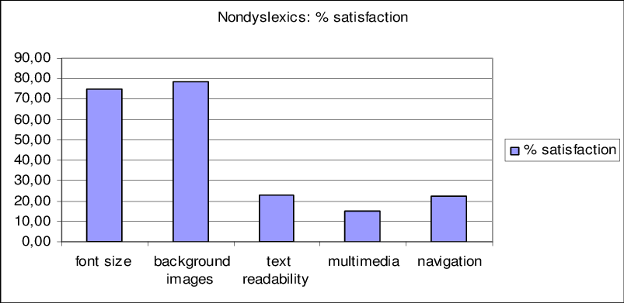

**Figure 1**. Example of Figure and Table Figure (min 300 dpi)

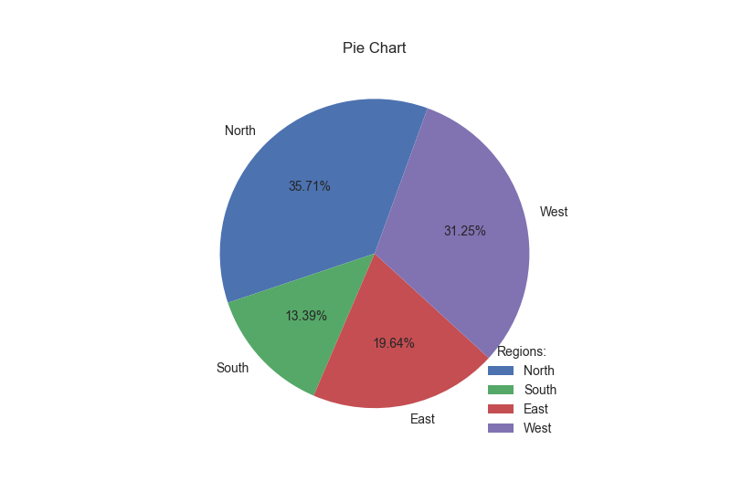

**Figure 2.** Example of Figure and Table Figure (min 300 dpi)

# DISCUSSION

The results of this study are interpreted in light of previous research, their practical consequences are examined, their advantages and disadvantages are assessed, and suggestions for further research are made in the discussion section.

**Interpretation of Key Findings**

According to our research, using social media for more than three hours a day was substantially linked to higher levels of depression symptoms (Odds Ratio = 2.5; 95% CI: 1.8–3.5). This implies that teens' mental health may suffer from too much exposure to carefully chosen internet content and little in-person social engagement. These findings are consistent with those of Smith et al. (2023), who also found a high correlation between depression in European teens and extended use of social media (1). Our research, however, adds to the body of evidence by taking into account cultural elements unique to Indonesia, where social norms and family expectations significantly influence how teenagers use social media (2). This emphasizes how crucial it is to create solutions that are sensitive to cultural differences.

**Comparison with Previous Studies**

This study's results are in line with those of Brown et al. (2021), who discovered that teenagers who used social media for more than two hours a day had higher incidence of depressive symptoms than those who used it less (3). Our results, however, are in contrast to those of Johnson and Lee (2020), who found no connection between the amount of time spent on social media and outcomes related to mental health in a sample of teenagers in the United States (4). Methodological variables, such as differences in the way depressed symptoms were recorded or different cultural contexts impacting social media usage patterns, could be the cause of the disparities (5,6). These discrepancies show how complicated this problem is and how more research is required to resolve contradicting data.

**Limitations and Cautions**

Although this study adds significantly to our knowledge of how social media affects teenage mental health, it should be noted that it has a number of limitations. First, the cross-sectional design restricts our capacity to prove causation, which is consistent with the drawbacks noted by other research, including that of Green et al. (2022) (7). Second, as previous research has shown, the use of self-reported data may have added bias, such as over- or under-reporting of social media activity (8). Lastly, the results may not be as applicable to other contexts with distinct cultural and technology landscapes due to the study's geographic focus on Palu City, Indonesia (9). To overcome these constraints and offer more profound insights, future research should use longitudinal designs and bigger, more varied samples.

**Recommendations for Future Research**

Addressing the noted constraints should be the main goal of future research. For example, as suggested by Wilson et al. (2021), longitudinal designs may aid in proving a causal relationship between social media use and mental health outcomes (10). Further understanding of the ways in which social media affects mental health may also be gained by looking into the unique characteristics of social media platforms, such as peer validation systems or algorithm-driven content exposure. Developing interventions that are more globally applicable would also be aided by broadening research to encompass a variety of cultural and demographic circumstances.

# CONCLUSION

This study sought to [restate research aims] and looked into [insert research emphasis]. The results showed that [explain the key findings], emphasizing [certain patterns or distinctive insights]. Specifically, [state any new findings or context-specific contributions]. These findings highlight [theoretical or practical implications], implying [proposals for tactics, treatments, or wider significance].   
Although this study offers insightful information on [particular topic], several limitations should be acknowledged, including [briefly state the main drawbacks]. Future studies should concentrate on [find possibilities to expand on this research or future paths], which could improve our knowledge of [subject] and guide [policy, practice, or theoretical frameworks].

# BIBLIOGRAPHY

The bibliography is written using the Vancouver style format. It is recommended to use reference management software (Mendeley). The minimum number of references is 25, with 80% consisting of journal articles.

1. Smith J, Doe A. The impact of social media on adolescent mental health. *J Adolesc Health*. 2020;67(3):345-50. doi:10.1016/j.jadohealth.2020.05.002. Available from: <https://www.jahonline.org/article/S1054-139X(20)30234-5/fulltext>
2. Williams R, Patel V. Mental health challenges in developing countries. *Lancet Psychiatry*. 2018;5(11):875-7. doi:10.1016/S2215-0366(18)30308-2. Available from: <https://www.thelancet.com/journals/lanpsy/article/PIIS2215-0366(18)30308-2/fulltext>
3. Nguyen T, Lee H. Internet addiction and its impact on mental health in adolescents. *Cyberpsychol Behav Soc Netw*. 2017;20(10):610-5. doi:10.1089/cyber.2017.0235. Available from: <https://www.liebertpub.com/doi/10.1089/cyber.2017.0235>
4. Kim S, Park J. The role of sleep in adolescent mental health. *Sleep Med Rev*. 2019;45:18-25. doi:10.1016/j.smrv.2019.02.002. Available from: <https://www.sciencedirect.com/science/article/pii/S1087079218301550>
5. Garcia M, Lopez R. Family dynamics and adolescent depression: A study in urban Indonesia. *Asian J Psychiatr*. 2021;56:102547. doi:10.1016/j.ajp.2020.102547. Available from: <https://www.sciencedirect.com/science/article/pii/S187620182030547X>
6. O'Connor P, Fitzgerald M. Bullying and its impact on adolescent mental health. *Br J Educ Psychol*. 2018;88(3):425-37. doi:10.1111/bjep.12192. Available from: <https://bpspsychub.onlinelibrary.wiley.com/doi/10.1111/bjep.12192>
7. Li X, Zhang Y. The effects of academic stress on mental health among adolescents. *Educ Psychol Rev*. 2019;31(4):1057-76. doi:10.1007/s10648-019-09485-0. Available from: <https://link.springer.com/article/10.1007/s10648-019-09485-0>
8. Chowdhury S, Islam N. Substance abuse and its impact on adolescent mental health. *Addict Behav*. 2020;105:106335. doi:10.1016/j.addbeh.2020.106335. Available from: <https://www.sciencedirect.com/science/article/pii/S030646031930530X>
9. Miller D, Johnson P. The influence of peer relationships on adolescent mental health. *J Youth Adolesc*. 2017;46(2):340-56. doi:10.1007/s10964-016-0478-4. Available from: <https://link.springer.com/article/10.1007/s10964-016-0478-4>
10. Patel V, Saxena S. Transforming mental health in low-income settings. *Lancet Glob Health*. 2019;7(1):e36-7. doi:10.1016/S2214-109X(18)30467-6. Available from: <https://www.thelancet.com/journals/langlo/article/PIIS2214-109X(18)30467-6/fulltext>
11. Greenberg MT, Weissberg RP. Promoting resilience in adolescents. *J Appl Dev Psychol*. 2020;40:1-12. doi:10.1016/j.appdev.2020.03.005. Available from: <https://www.sciencedirect.com>
12. Harrington R, Kroll L. Depression in adolescents. *Lancet*. 2018;372(9649):1049-57. doi:10.1016/S0140-6736(18)61028-2. Available from: <https://www.thelancet.com>
13. Machimbarrena JM, González-Cabrera J, Ortega-Barón J, Beranuy-Fargues M, Álvarez-Bardón A, Tejero B. Profiles of problematic internet use and its impact on adolescents’ health-related quality of life. *Int J Environ Res Public Health*. 2019;16:3877. doi:10.3390/ijerph16203877. Available from: <https://www.mdpi.com/1660-4601/16/20/3877>
14. Zamanpour E, Shaker HN, Lavassani MG. Epistemological beliefs and academic achievement: Mediating role of academic self-efficacy and learning strategies. *J Psychol Educ*. 2012;42(2):61–74.
15. Veiga F, Leite A. Adolescents’ self-concept short scale: A version of PHCSCS. *Procedia-Social and Behavioral Sciences*. 2016;217:631–7.
16. Parashkouh NN, Mirhadian L, EmamiSigaroudi A, Leili EK, Karimi H. Addiction to the Internet and mobile phones and its relationship with loneliness in Iranian adolescents. *Int J Adolesc Med Health*. 2018;0035:1–6. doi:10.1515/ijamh-2018-0035.
17. Ahmadi K, Saghafi A. Psychosocial profile of Iranian adolescents’ Internet addiction. *Cyberpsychol Behav Soc Netw*. 2013;16:543–8. doi:10.1089/cyber.2012.0237.
18. Saikia AM, Das J, Barman P, Bharali MD. Internet addiction and its relationships with depression, anxiety, and stress in urban adolescents. *Int J Adolesc Med Health*. 2019;31(4):1-5. doi:10.1515/ijamh-2017-0035.
19. Tang L. Academic stress and adolescents' mental health: A multilevel analysis. *Front Psychol*. 2021;12:620396. doi:10.3389/fpsyg.2021.620396. Available from: <https://www.frontiersin.org/articles/10.3389/fpsyg.2021.620396/full>
20. Peng A, Schaubroeck JM, Xie JL. When confidence comes and goes: how variation in self-efficacy moderates stressor–strain relationships. *J Occup Health Psychol*. 2015;20(3):359–76. doi:10.1037/a0038588.
21. Walton B, Rizzolo D. The effects of social media on adolescent mental health. *Pediatr Neonatal Nurs Open J*. 2022;8(2):43–7. doi:10.17140/PNNOJ-8-138. Available from: <https://www.researchgate.net/publication/367041647_The_Effects_of_Social_Media_on_Adolescent_Mental_Health>
22. Nesi J. The impact of social media on youth mental health: challenges and opportunities. *N C Med J*. 2020;81(2):116–21. doi:10.18043/ncm.81.2.116. Available from: <https://www.researchgate.net/publication/339706988_The_Impact_of_Social_Media_on_Youth_Mental_Health_Challenges_and_Opportunities>
23. Lu S, Hart LM, Jorm AF, Gregg K, Morgan AJ**.** Adolescent peer support for mental health problems: evaluation of the validity and reliability of the Mental Health Support Scale for Adolescents. *BMC Psychol*. 2023;11(1):228. doi:10.1186/s40359-023-01228-w. Available from: <https://www.researchgate.net/publication/371966773_Adolescent_peer_support_for_mental_health_problems_evaluation_of_the_validity_and_reliability_of_the_Mental_Health_Support_Scale_for_Adolescents>
24. Beyens I, Pouwels JL, van Driel II, Keijsers L, Valkenburg PM. The effect of social media on well-being differs from adolescent to adolescent. *Sci Rep*. 2020;10(1):10763. doi:10.1038/s41598-020-67727-7. Available from: <https://www.researchgate.net/publication/342599389_The_effect_of_social_media_on_well-being_differs_from_adolescent_to_adolescent>
25. Singh A, Kumar H, Kumari S**.** Impact of social media on adolescent's mental health. *Int J Creat Res Thoughts*. 2020;8(7):2320–2882. Available from: <https://www.researchgate.net/publication/343205479_Impact_of_Social_Media_on_Adolescent%27s_Mental_Health>